**Sample Problem 1: School Results Application**

**Class Diagram**

The class diagram represents the structure of a school results application where students have subjects, and their scores are calculated for grades.

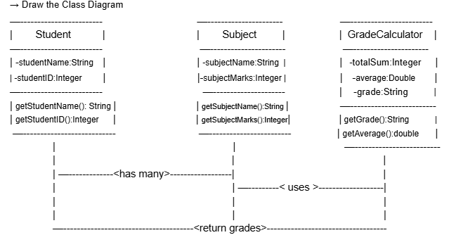

**Object Diagram**

An object diagram provides a snapshot of the Student and their Subject objects at a particular point.

**Example:**

* **Student**: John
* **Subjects**: Maths, Science
* **Marks**: 90, 85

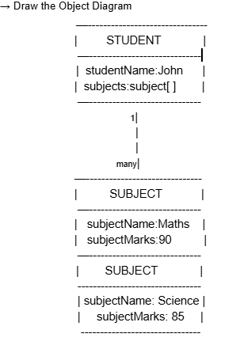

**Sequence Diagram**

The sequence diagram shows how objects interact to calculate grades.

**Scenario:** A student requests their grade based on marks in subjects.

**Actors:**

1. Student
2. GradeCalculator

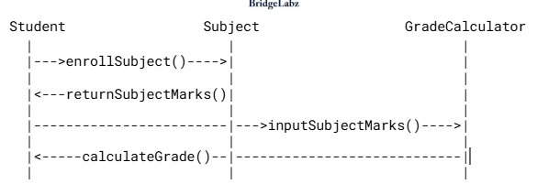

**Sample Problem 2: Grocery Store Bill Generation Application**

**Class Diagram**

The class diagram models the system where a customer buys products, and the bill is generated.

**Diagram Description:**

* **Classes**: Customer, Product, BillGenerator
* **Relationships**:
  + A Customer can purchase multiple Product items (Composition).
  + BillGenerator computes the total for the Customer.

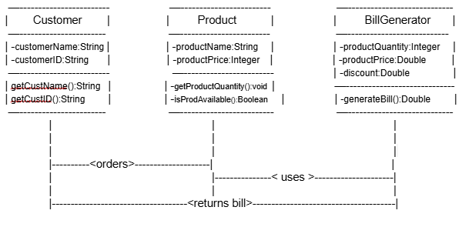

**Object Diagram**

An object diagram shows the details of a Customer and the Product objects they have purchased.

**Example:**

* **Customer**: Alice
* **Products**:
  + Apples (2 kg at $3 per kg)
  + Milk (1 liter at $2 per liter)

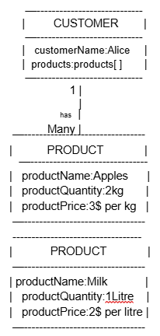

**Sequence Diagram**

The sequence diagram shows the process of bill generation for a customer.

**Scenario:** A customer checks out at the grocery store, and the total bill is generated.

**Actors:**

1. Customer
2. BillGenerator

